Manual for automated python & java workflow in ImageJ for Caspase and TUNEL assays in Zebrafish embryos

Nika Chakhunashvili

Nika.chakhunashvili.1@iliauni.edu.ge

Helmholtz-Zentrum Dresden-Rossendorf (HZDR)


Introduction

This manual describes the setup, configuration, and execution of the unified Python and ImageJ pipeline. The pipeline automates color-channel verification, chronological specimen pairing, interactive DAPI brain Region of Interest (ROI) selection, signal quantification, quality control mask generation, and group-wise control subtraction (AK vs. oAK and mAk vs. oAk) for 10x zebrafish images for Caspase and (Scale = 1.3870 px/um) and 40x zebrafish brain fluorescence images in the case of TUNEL (Scale = 5.5556 px/um).
System requirements:
- ImageJ / Fiji (64-bit Windows executable: ImageJ.exe)
- Python 3.8+: batch_caspase_10x.py for Caspace assay and tunel_full_pipeline.py for TUNEL assay.
- ImageJ Macro: process_caspase_10x_brain.ijm for Caspace assay and process_tunel_40x.ijm for TUNEL assay.
Required Python Packages:
Install the required dependencies via terminal or command prompt if necessary:
pip install numpy pandas pillow
tkinter and subprocess are included in standard Python distributions.

Caspase Assay

This pipeline is for the Caspase assay with images of 10x magnification, Scale = 1.3870 px/um. (For safer calculations it is better to check the microscope’s magnification dimensions by opening the corresponding *.czi files within Qupath software to verify this scaling, preferably within the microscope’s computer where the images were taken!).

Antibody Tagging & Match Key Conventions:
To perform control background subtraction, image filenames must include condition tags:
- AK: Primary antibody-stained experimental sample.
- oAK: Secondary-only negative control sample.
The pipeline automatically identifies AK and oAK tags and extracts matching pair keys. For example, Fish01_Slice2_AK.tif and Fish01_Slice2_oAK.tif are automatically linked as paired specimens.

Execution Workflow

Step 1: Execute the python Script
Run the pipeline script from your Python environment shown by the arrow on the image (shown images display Spyder interface):
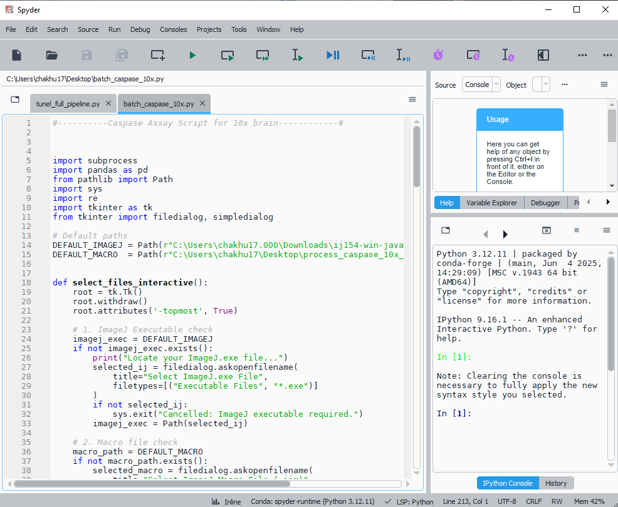

Step 2: Interactive GUI Prompts
First pop-up window asks for the ImageJ.exe file. Click open after the selection of the file: 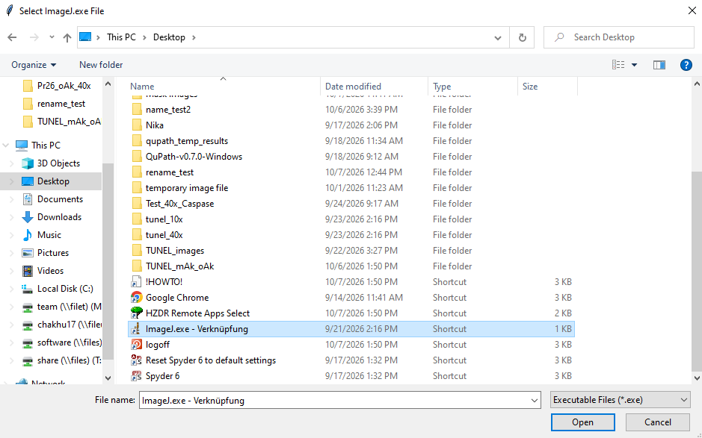

Next, it asks for the location of process_caspase_10x_brain.ijm file. After locating, click open: 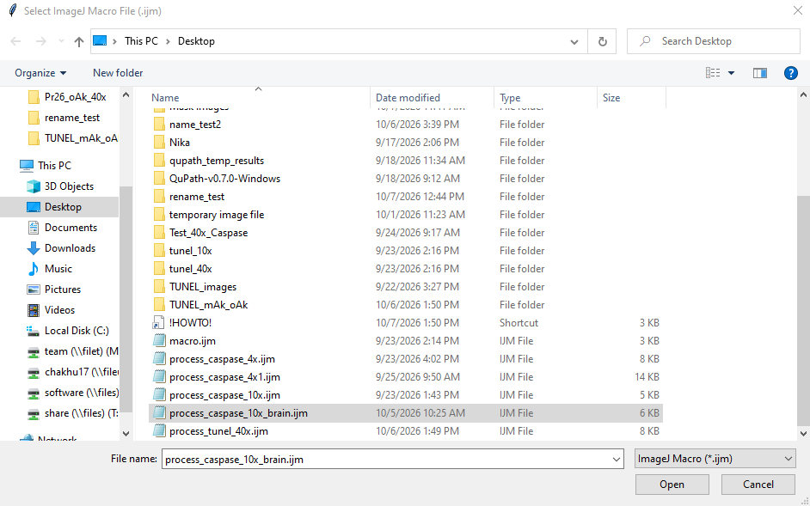
Then it asks for the location of the folder where all the Caspase 10x images of interest are located. After locating, click ‘select folder’: 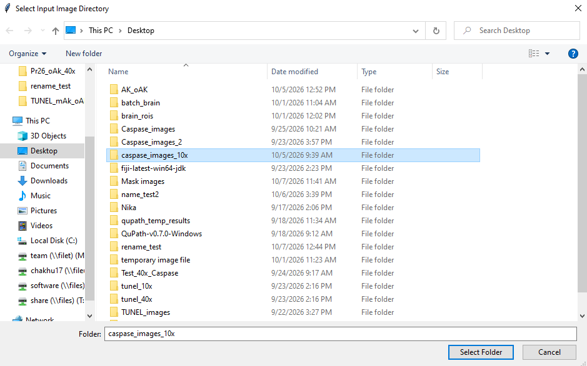

Then, you are asked where to save the final produced csv file with all the calculations: 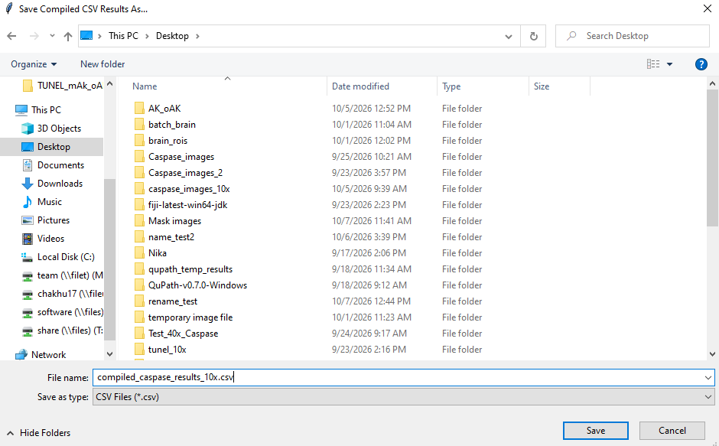

Finally, it asks about the sensitivity of the signal detection with given options for higher or lower sensitivity:
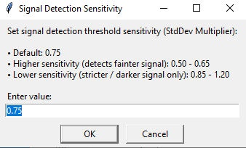

Operational Processing Phases

Phase A: Calibration & Interactive Brain ROI Selection:
- Java script for ImageJ loads each image, converts it to 8-bit gray scale, and applies the 10x spatial scale (1.3870 px/um).
- A pop-up dialog prompts the user to outline the brain tissue using ImageJ's Freehand Tool: 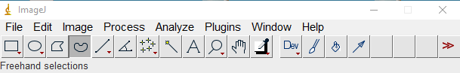

- Brain Selection Procedure:
- Trace the brain tissue outline with the mouse and click OK.
- No-Brain Option: If an image contains no valid brain tissue or should be excluded, click anywhere outside to deselect all ROIs (yellow outlines) if there are any, then click OK as shown in the image below: 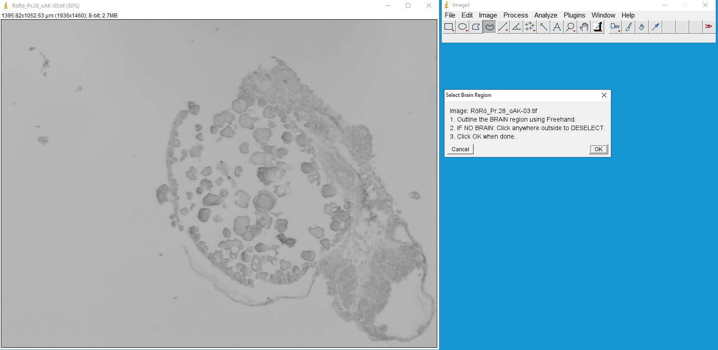
- After clicking OK, script automatically displays another image for outlining while it detects and outlines the signal and calculates all the parameters for the previous image in the background.

Phase B: Optical Density Calibration & Signal Segmentation
- The macro applies uncalibrated Optical Density (OD) transformation to measure true tissue absorption:
OD = log₁₀(255/Gray Value)
- Raw 8-bit intensity statistics within the brain ROI (µ_{Brain_Raw}, $σ$_{Brain_Raw}) determine the darkness cutoff threshold:
Cutoff Threshold = µ_{Brain_Raw} – k * $σ$_{Brain_Raw}
- Pixels darker than the cutoff threshold (0 to Cutoff Threshold) within the brain region are classified as positive Caspase signal.

Phase C: QC Artifact Generation & Specimen Routing
- QC Overlay Mask: Generates flattened RGB masks with a red outline for the brain ROI and a cyan outline for detected Caspase signal ROIs, saved inside a qc_masks subfolder as QC_mask.png.
- No-Brain Specimens: Images lacking a selected brain ROI are copied to a no_brain directory and flagged as No Brain in the output dataset.

Phase D: Post-Processing & Background Subtraction
- Summarizes sample results and computes baseline controls.
- Calculates the mean NIOD and IOD for all oAK negative control images sharing the same Pair_Key.
- Calculates net signal metrics for all experimental (AK) images:
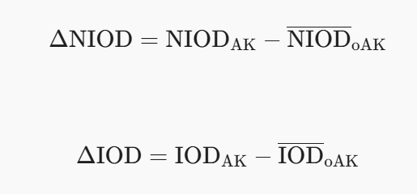

Output Data Structure & Metrics

The output CSV file compiles the following quantitative parameters:
Field Name: Label
Description: Original image filename
Units/Formula: Filename String

Field Name: Status
Description: Image processing outcome
Units/Formula: Processed / No Brain

Field Name: Antibody_Type
Description: Experimental condition tag
Units/Formula: AK / oAK / Unknown

Field Name: Area_brain_um2
Description: Total area of the selected brain tissue ROI
Units/Formula: µm²

Field Name: MeanOD_brain
Description: Mean Optical Density across the entire brain ROI
Units/Formula: OD Value

Field Name: MinOD_brain / MaxOD_brain
Description: Minimum and maximum Optical Density in the brain ROI
Units/Formula: OD Value

Field Name: Area_signal_um2
Description: Surface area of positive Caspase staining
Units/Formula: µm²

Field Name: MeanOD_signal
Description: Mean Optical Density of positive Caspase pixels
Units/Formula: OD Value

Field Name: IOD
Description: Integrated Optical Density (Area_signal * MeanOD_signal)
Units/Formula: µm² * OD

Field Name: NIOD
Description: Normalized Integrated Optical Density (IOD / Area_brain_um2)
Units/Formula: OD Ratio

Field Name: Matched_oAK_NIOD
Description: Mean baseline NIOD of matching oAK negative controls
Units/Formula: OD Ratio

Field Name: Matched_oAK_IOD
Description: Mean baseline IOD of matching oAK negative controls
Units/Formula: µm² * OD

Field Name: Delta_NIOD_AK_minus_oAK
Description: Primary normalized net Caspase outcome metric (NIOD_AK - NIOD_oAK)
Units/Formula: Net OD Ratio

Field Name: Delta_IOD_AK_minus_oAK
Description: Total net Caspase outcome metric (IOD_AK - IOD_oAK)
Units/Formula: Net µm² * OD

Field Name: RawIntDen_brain
Description: Raw integrated intensity density of brain region
Units/Formula: Pixel Gray Values

Operational Notes & Troubleshooting

- Missing oAK Control Warning: If an AK sample lacks a corresponding oAK file with a matching prefix, the script flags [WARNING: Missing matching oAK control image!] in the terminal log and outputs N/A for $\Delta\text{NIOD}$ and $\Delta\text{IOD}$.
- Excel Lock Errors: Ensure that caspase_raw_results_temp.csv or target compiled CSV files are closed in Microsoft Excel or other spreadsheet applications before starting execution.
- Re-running Batches: To re-analyze a directory, delete or move the generated qc_masks/ and no_brain/ folders to ensure clean file iterations.

TUNEL Assay

